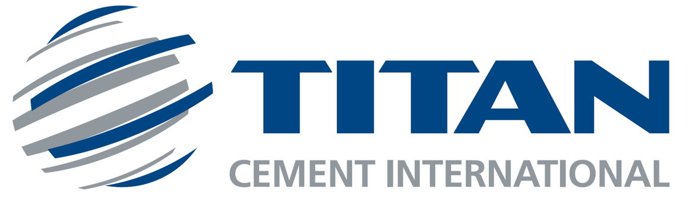

Intention to list TITAN America in the US equity market

Brussels, 9 May 2024, 08:30 CEST - Titan Cement International SA (Euronext Brussels, Euronext Paris and ATHEX, “TITC”) announces its intention to proceed with the IPO of its US business (“Titan America”) raising funds that will facilitate the Group’s and Titan America’s future growth and unlock new opportunities. Titan America, a $1.6 billion sales business, is a leading and fully integrated player in the high-growth economic mega-regions of the US East Coast, with operations and leading market positions across Florida, the Mid-Atlantic, and Metro New York/New Jersey. ​
​The listing is anticipated to take place on a stock exchange in New York and will be accompanied by an IPO of a minority stake, consistent with the typical percentage of company stock sold in US IPOs, without creating any incremental tax burden. The transaction is anticipated to be completed in early 2025.

- This press release may be consulted on the website of Titan Cement International SA: https://ir.titan-cement.com
- For further information, please contact Investor Relations at +30 2102591257
- This press release does not constitute an offer to sell or the solicitation of an offer to buy any securities. Any offers, solicitations or offers to buy, or any sales of securities will be made in accordance with the registration requirements of the Securities Act of 1933, as amended (the "Securities Act"). This announcement is being issued in accordance with Rule 135 under the Securities Act.

Press contact :

 |  | Gunther De Backer  Partner, Backstage Communication
    Email: gunther@backstagecom.be
    Mobile: +32475903909
    Facebook: BackstageCommunicationSPRL
    Website: backstagecom.be

