

Press Release For Immediate Release

25 June 2025

Hybrid Software’s CLOUDFLOW Colorspace Honored with 2025 PRINTING United Alliance Pinnacle Award
The cutting-edge color management module, purpose-built for the complex demands of the labels and packaging industry


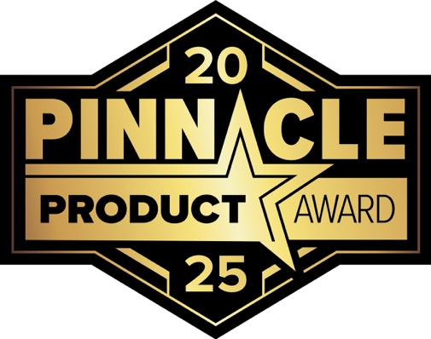

(Ghent, Belgium) Hybrid Software, a leading manufacturer of productivity software for the labels and packaging industry and PRINTING United Alliance corporate supplier member, is proud to announce it has been awarded a 2025 Pinnacle Award, recognizing the company’s outstanding innovation in the non-output category. This is the second award for the product, following a recent recognition from EDP for “Best Color Management Solution.”

The Pinnacle Awards are the printing industry’s most prestigious honor, celebrating exceptional products and technologies that advance quality, capability, and productivity. A highly qualified panel of judges across the printing industry evaluated the annual contest’s 150+ entries in more than 50 categories spanning analog, digital, output, and non-output technologies.
Colorspace is a unique product which combines the powerful color management products of ColorLogic with the automation of Hybrid Software’s CLOUDFLOW workflow to deliver consistent, precise color reproduction across diverse substrates and printing technologies. Its browser-based interface integrates effortlessly with ERP, MIS, and W2P systems, automating every stage from estimation to output. The result: better customer communication, faster turnarounds, reduced manual workload, and a streamlined path to exceptional print quality.
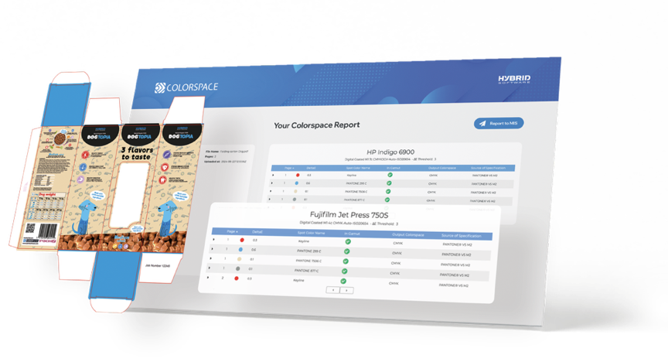

“We are truly honored to receive the 2025 Pinnacle Award for CLOUDFLOW Colorspace,” said Christopher Graf, VP/GM Color Business Unit of Hybrid Software. “This recognition underscores our commitment to solving real-world challenges in labels and packaging through innovation that delivers measurable impact. CLOUDFLOW Colorspace was developed specifically to simplify color management for our customers, improving accuracy and consistency while reducing time and waste. This award is a testament to the talent and dedication of our global team and reinforces our mission to lead the industry forward with smart, scalable technology.”

See the Award-Winning Technology at PRINTING United Expo 2025

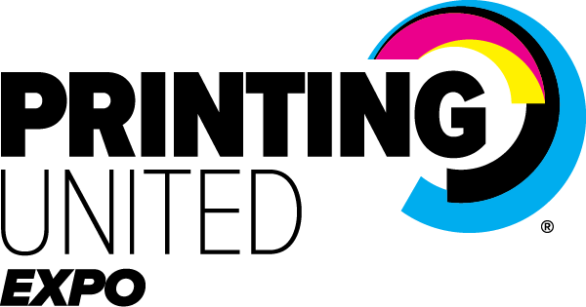

Hybrid Software is excited to announce that they’ll be exhibiting the award-winning color management software at PRINTING United Expo 2025 in Orlando on October 22–24. Visitors can experience the innovation firsthand at Booth 3610.

“A special note of congratulations to Hybrid Software and all those honored this year for their outstanding work in the 2025 Pinnacle Awards Program,” said Lindsay Ferrari, Program Administrator, PRINTING United Alliance. “Each Pinnacle Award recipient reflects the bold thinking and technical excellence that continues to elevate and move our industry forward.”

ENDS
About the Pinnacle Awards Program
For more information about the Pinnacle Awards program, and to learn how to become involved in future programs, visit: https://pinnacleawards.printing.org/.
To learn more about becoming a member of PRINTING United Alliance to participate in exclusive programs such as the Pinnacle Awards, as well as have access to the latest in industry education, training, certification and more, visit: www.printing.org/membership.

A full online showcase gallery of the 2025 Pinnacle Award winners is available here: https://pinnacleawards.printing.org/.

About Hybrid Software

Headquartered in Ghent, Belgium, with offices across Europe, the Americas, China, and a global partner network, Hybrid Software is a leading enterprise software company specializing in productivity tools for the graphic arts industry.

Its innovative solutions—including the PACKZ native PDF editor, CLOUDFLOW production workflow, iC3D 3D visualization software, ColorLogic color management solutions, and advanced print quality technology—deliver key advantages such as native PDF workflows, enterprise cloud solutions, scalable architecture, low total cost of ownership, and seamless integration with leading MIS systems and output devices.

Hybrid Software is trusted by thousands of customers worldwide across all areas of prepress and print, including labels and packaging, folding cartons, corrugated, wide format, and digital printing.

www.hybridsoftware.com

Contact: marketing@hybridsoftware.com

Press Contacts:

Chief Marketing Officer
Steven Steenhaut
Email: stevens@hybridsoftware.com
Tel: +32 478 88 30 82

HYBRID Software NV
Guldensporenpark 18 Block B 9820 Merelbeke, Belgium.

HYBRID Software GmbH
Uhlandstr. 9, 79102 Freiburg, Germany.

HYBRID Software Inc.
One South State Street, Newtown, PA 18940.

