Kinepolis Group accelerates transition to laser
Cinionic Laser Light Upgrades to transform screens across Europe
Kortrijk, 22 June 2020 – Cinionic, the Barco, CGS, and ALPD cinema joint venture, announces plans to upgrade Kinepolis cinemas with its exclusive RGB+ laser solutions, continuing the longstanding relationship between the companies. Global exhibitor Kinepolis Group operates nearly 1.100 screens across nine countries including the US, Belgium, Spain, France, the Netherlands and Canada. As part of the ongoing transition to all-laser, Kinepolis adds Cinionic’s Laser Light Upgrades to its mix of new technology solutions for moviegoers.
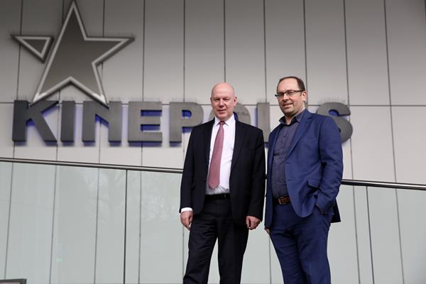
Cinionic is the cinema laser company with longstanding laser expertise and the largest portfolio of laser solutions designed specifically for cinema. Laser Light Upgrades allow theaters to reuse existing projectors and enjoy the benefits of laser projection. Through the addition of RGB+ laser technology, upgraded Series 2 projectors produce brighter, clearer images and are more energy efficient and less maintenance intensive. The upgrade can be completed in as few as four hours, minimizing any downtime for the theater.
“In our mission to offer the best movie experience, it is important to be the frontrunner in laser, committed to delivering an all-laser Cinema circuit for our audiences,” said Eddy Duquenne, CEO of Kinepolis Group. “Like Cinionic, we believe in innovation in cinema, and these laser upgrades allow us to maintain perfect quality and experience for our guests while keeping both our initial investment and ongoing costs down for years to come.”
Kinepolis was quick to see the potential and success of laser with the introduction of their premium brand, Laser ULTRA, establishing them as an early leader in the technology. In 2018, Kinepolis announced an exclusive partnership with Cinionic to power 300 screens with new laser projectors. Today’s announcement signals Kinepolis’ ongoing commitment to laser as the illumination technology of the future for cinema projection and accelerates their renewal strategy by upgrading their existing lamp projectors to the latest standard.
“Kinepolis continues to forge new cinema experiences, and we are proud to power those experiences with advanced technology solutions and services,” said Wim Buyens, CEO, Cinionic. “Through their sustained investment in laser, Kinepolis offers the moviegoers of tomorrow an entertainment experience that is unmatched and better for the planet.”

About Cinionic
Founded in 2018 as a cinema joint venture between Barco, CGS, and ALPD, Cinionic unites global leaders committed to creating a new visual standard and moving the cinema industry forward. Cinionic’s future-ready enhanced services and technology solutions provide compelling cinema experiences. The company’s world-class technology portfolio includes award-winning laser projectors, HDR, integrated media servers, and premium cinema experiences, among other innovations.
With more than 90.000 projectors installed globally, Cinionic is trusted by more than 200 exhibitors to help capture audiences at multiple touchpoints in their cinema journey and keep them coming back for more. Today, more than half of the world’s movie theaters are illuminated by Cinionic.
Cinionic has offices in Belgium, United States, Hong Kong, and Mexico.
Visit www.cinionic.com and follow us on Twitter, LinkedIn, Facebook or YouTube for more information.

About Kinepolis Cinemas
Kinepolis Group NV was formed in 1997 as a result of the merger of two family-run cinema groups and was listed on the stock exchange in 1998. Kinepolis offers an innovative cinema concept which serves as a pioneering model within the industry. In addition to its cinema business, the Group is also active in film distribution, event organization, screen publicity and property management.
In Europe, Kinepolis Group NV has 55 cinemas spread across Belgium, the Netherlands, France, Spain, Luxembourg, Switzerland and Poland. Since the acquisition of Canadian movie theatre group Landmark Cinemas and American movie theatre group MJR, Kinepolis also operates 46 cinemas in Canada and 10 in the US.
In total, Kinepolis Group currently operates 111 cinemas worldwide, with a total of 1.079 screens and almost 200.000 seats. Kinepolis employs 4.600 people, all committed to giving millions of visitors an unforgettable movie experience. More information on www.kinepolis.com/corporate.

About Barco
Barco designs technology to enable bright outcomes around the world. Seeing beyond the image, we develop visualization and collaboration solutions to help you work together, share insights, and wow audiences. Our focus is on three core markets: Enterprise (from meeting, classroom and control rooms to corporate spaces), Healthcare (from the radiology department to the operating room), and Entertainment (from movie theaters to live events and attractions). In 2019, we realized sales of 1,083 billion euro. We have a global team of 3.600 employees, whose passion for technology is captured in 400 granted patents.
For more information, visit us on www.barco.com, follow us on Twitter (@Barco), LinkedIn (Barco), YouTube (BarcoTV), or like us on Facebook (Barco).
© Copyright 2020 by Barco

Voor meer informatie kunt u contact opnemen met
Carl Vanden Bussche
Vice President Investor Relations
Barco nv
Telefoon +32 56 26 23 22
carl.vandenbussche@barco.com

